How to Pull FAIM Account Statements

FAIM account statements are generally updated and ready to pull on the 4th of each month.

- Login to VistaShare: https://www.vistashare.com/ot2/security/login/
- Click on the “Reports” tab
- In the column/tree on the left, click on “Standard Reports” to expand
- Click on “IDA / CSA” folder to expand
- Click on “Participant Summary Info”
- In the list of reports to the right, click on “IDA Statements – IDA Monthly Statements”
- A popup window will open
- In the Query drop-down box, select “Monthly Statement”
- Select information in the fields as noted below:
- Collaborative Name: select your agency
- Partner Financial Institution: select “Bremer Bank”
- Program Type: select “Adult (AFI)”
- Account Status: “Application, Enrollment, Open” should be highlighted
- Statement Begin Date: select the first day of the previous month
- Statement End Date: select the last day of the previous month
- You may select any date range but 1st-last day of previous month is recommended.
- Message on Statement field – adding a message here will put it on all statements pulled.
- You must put something in this field (x or .) or the report may error out.
- Click on “Run Report”
- Wait for the report to generate, then click on “IDA Statement”
- In the warning popup box click “I Understand”
- Click on “Open” to view the downloaded account statements, then save to your local network.
- Review the account statements to determine if each client is on track to reach their saving goal within 24 months, if they made a deposit during the month, etc. If you notice updates are needed to: local coach name/contact information, asset track, client contact information, etc. email suet@wcmca.org.
- If participants are not using the VistaShare client portal to monitor their savings/match balance, the coach is to provide a monthly FAIM statement to those clients.

Example of monthly FAIM statement: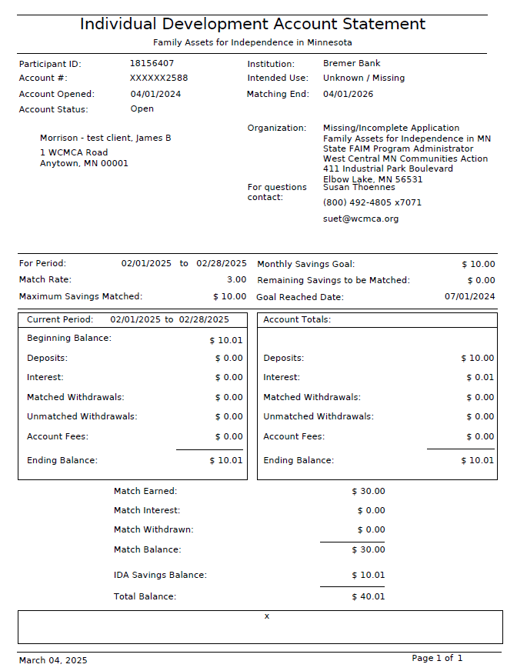

How to Pull a Participant Account Summary/Transaction Record

The account statement summary is a deposit/withdrawal record of the participant’s FAIM account.

- Click on the “Reports” tab
- In the column/tree on the left, click on “Standard Reports” to expand
- Click on the “IDA / CSA” folder to expand
- Click on “Participant Summary Info”
- In the list of reports to the right, click on “IDA Statement Summary Report”
- Select information in the fields as noted below:
  - Enter the participant’s – FAIM savings account number or SSN
  - Statement Begin Date: enter their date of first deposit
  - Statement End Date: enter today’s date
- Click “Run Report”. Once it generates, click on “IDA Statement Summary Report”
- In the warning popup box click “I Understand”
- Click on “Open” to view the downloaded transaction history then save to your local network.

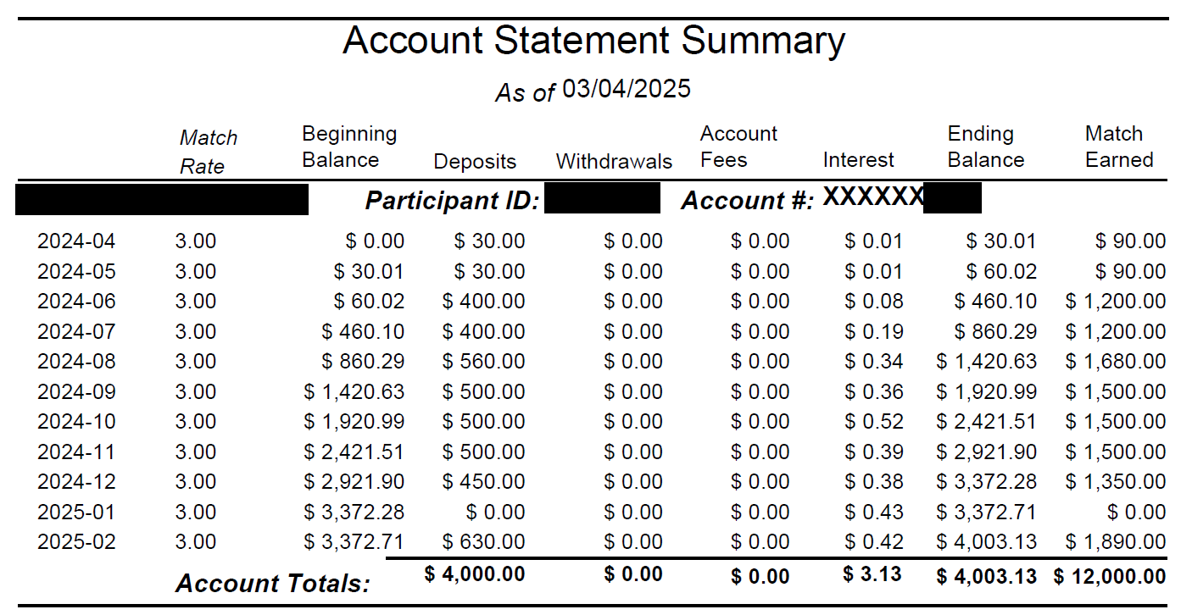
Example of a participant transaction record:

