FAIM - Family Assets for Independence in Minnesota
Program Evaluation + Follow-up Survey report
April 2021

Table of Contents

￼￼Table of Contents 1
About The Improve Group 2
About the evaluation 3
About the FAIM Program 3
Program Statistics January 2011-December 2019 3
Findings 3
￼Introduction 5
About the Family Assets for Independence in Minnesota (FAIM) Program 6
Methodology 6
Findings 7
FAIM Program Statistics 7
Participant success rates vary by demographics and financial indicators at intake. 8
Success rates are higher for the business and education programs than for a house purchase. 8
The program has varying success for different groups, depending on gender, race/ethnicity, and age.￼ 9
Credit scores upon entry are not a clear predictor of success. 11
Participants with past financial experiences such as the use of bank accounts, and home ownership are more likely to succeed in the program. 12
Participants report long-term positive outcomes after program completion 14
Former participants felt supported by the FAIM program elements. 17
Former participants made lasting changes to their financial assets and wellbeing. 18
Discussion 25
Appendix: Participant survey Demographics 27

About The Improve Group
The evaluation was completed by The Improve Group (IG) is a woman-owned, full-service evaluation, research, and strategic planning and facilitation consulting firm based in St. Paul, Minnesota. We are committed to helping local, national, and international organizations make the most of information, navigate complexity, and ensure their investments lead to meaningful, sustained impact. That commitment is connected to our vision, which is that mission-driven organizations will effectively develop more resilient, equitable, and thriving communities.

Executive Summary

About the evaluation

About the FAIM Program
The Family Assets for Independence in Minnesota (FAIM) Program is a 30-month matched savings project that helps Minnesota low-wage earners build assets in the state through enrollment in one of the following tracks:
- purchase of a first home
- pursuit of higher education
- starting a small business

Once enrolled, participants reach their goal by making monthly deposits from their earned income into a Family Asset Account (savings account opened through the program). Deposits made to the account within 24 months may be matched 3:1 by the program (up to $2,000 maximum lifetime savings per household).

Program Statistics January 2015-December 2019
Total number of accounts opened | 1,194
Total accounts successfully completed | 688
Overall success rate | 58%
Total participant dollars saved overall | $704,229
Total match dollars used overall | $1,745,346

For this evaluation report data was taken from two main sources, the organization’s database and a survey of past participants. The FAIM database was used to look at success rates and how they vary by demographic characteristics.
The follow-up survey was distributed in March/April 2021 to 1,067 participants whose email addresses were current and on file. All of those invited to the survey participated in the FAIM program between January 2015 and December 2019. No sample was taken and 169 individuals responded.

Findings
The FAIM program has the highest success rates for those in the education (71%) and business development programs (67%), with the first-time home buyer success rates being much lower at 46%. Survey participant responses point to an opportunity to change the application process for this program to better screen participants so that only those who are likely to succeed in obtaining access to loans to purchase a home at the end of the program are accepted. These rates may also point to a need for additional supports for those in the home buying program, or longer timelines (also suggested by survey respondents) given the amount of capital required to purchase a home.
Participant success rates vary by demographics and financial indicators at intake, pointing to an opportunity to offer greater supports for certain populations. Males have almost a 10% higher success rate than females in the FAIM program, while females make up a much higher percentage of program participants (71% overall). The FAIM program is most effective in serving Latino/Hispanic, Asian/Pacific Islander, and White participants. It is not as successful in achieving the same outcomes for its Multiracial, Native American/Alaskan Native and Black/African American participants. Given these findings the FAIM program may want to consider offering more targeted programming for individuals of certain demographic groups, perhaps partnering with specialized organizations, creating peer support groups of participants, or offering additional one to one coaching support.
Participants 19 years old and under had the highest completion rates of any age group, however they make up a very small percentage of participants (6%). This may prove to be a promising opportunity to expand offerings for younger participants as they are more likely to learn healthy financial habits from the start which can benefit them, and subsequent generations, from the beginning of their adult lives. This may also pair nicely with an expansion of the educational program, which has also proven to have the highest success rate. Given that participants can participate two times in a lifetime, this could be marketed as a starter opportunity to young participants.
Participants with past financial experiences such as the use of bank accounts and home ownership are more likely to succeed in the program. Participants who had a checking and/or savings account have higher rates of successfully completing the program than those who have not. Similarly, participants who owned a home at time of entry have a much higher likelihood of succeeding in the program, however they make up a small percentage of participants. These numbers indicate that there could be an opportunity for additional targeted education, support, and/or coaching for participants new to formalized banking activities.
Past FAIM program participants reported lasting changes to their assets. The large majority of successful respondents in the home ownership or business development tracks reported retaining their home or business (94%), and an additional 4% shared that they sold their initial home and purchased a home worth more, thereby increasing their net worth. Of the survey respondents who successfully completed the FAIM educational program, 88% also fully completed their post-secondary educational program, and 100% of those shared that their degree has been useful in meeting their work or career goals.
Past participants shared that the savings match dollars were the most helpful part of the FAIM program, followed by the financial literacy education, and finally the 1:1 coaching was still rated highly. The 1:1 coaching is typically just a few meetings per participation period, which may be why it was not seen as the most supportive element of the program. Many respondents are happy with the program the way it is. Many others would like to see more coaching and support available to participants, including additional home ownership and business mentoring.
Former participants made lasting changes to their financial assets, behaviors, and overall financial wellbeing. The large majority of survey respondents shared that they’ve been engaged in actively contributing to improving/building upon their credit score in positive ways, and have also taken actions such as reading their credit report, and repairing errors. Participants shared that they have been saving money for emergencies and retirements, and have assets including a vehicle, investments, and/or a home. All but a few survey respondents maintain a checking account, a savings account, and credit cards. The majority of respondents do not currently have overdue debt. However, a small majority (51%) are currently carrying a credit card balance for more than a month which is likely a reflection of the current economic state more than a year into the pandemic at the time of survey distribution. Student loans are the most commonly held form of debt carried by survey respondents. The majority of respondents (60%) reported being employed full time (35 or more hours per week), with an additional 5% self-employed full-time. The majority of respondents (57%) reported earning over $30,000 annually.
These results show that the program supports participants to make lasting changes for the better in their lives, and that, with additional program supports, even more participants have the potential to create better financial lives for themselves.
“My wife and I were first informed of FAIM through a banker friend that was familiar with the program. The FAIM expectations and criteria were presented in an easily understood format through friendly interactions with the program's administrators. Had it not been for FAIM we'd still be renting, paying more for a property that isn't ours while barely being able to screech by with our monthly obligations. After FAIM we have a home to call our own and the means to save each month which directly contributes to an improved future for our children and the basis for them to build generational wealth.”

Introduction

About the Family Assets for Independence in Minnesota (FAIM) Program
The Family Assets for Independence in Minnesota (FAIM) Program is a 30-month matched savings project that helps Minnesota low-wage earners build assets in the state through enrollment in one of the following tracks:
- purchase of a first home
- pursuit of higher education
- starting a small business

Once enrolled, participants reach their goal by making monthly deposits from their earned income into a Family Asset Account (savings account opened through the program). Deposits made to the account within 24 months may be matched 3:1 by the program (up to $2,000 maximum lifetime savings per household). The participant has up to an additional 6 months after the end of their saving period to obtain their asset, if needed.
FAIM helps participants change their saving and spending habits, including consumer debt reduction. Before accessing FAIM funds, the participant must successfully complete:
- a minimum of 12 hours of financial management training provided by the local agency
- an additional 10 hours of asset-specific training
- asset-specific requirements for their chosen track
FAIM funding is appropriated through state legislation.
The program:
- target enrollment is the working poor in Minnesota
- provides subsidies through matched payout rather than through tax breaks
- provides financial counseling and requires the account holder to complete financial education classes
FAIM participants must be 18 years of age, live in Minnesota while enrolled in FAIM, be a US citizen or eligible non-citizen, have earned income to deposit in savings monthly, have a household gross annual income below 200% of the federal poverty guideline, and have household net assets under $10,000.

Methodology
For this evaluation report data was taken from two main sources, the organization’s database and a survey of past participants. The FAIM database was used to look at success rates and how they vary by demographic characteristics. Overall demographics were also examined to see how well the survey respondents aligned with the total population of program participants. Data used from the database was from January 2015 to December 2019.
December 2019 was used as an end date in hopes of gaining a clearer picture of how participants have fared without the programmatic and economic implications of the COVID-19 pandemic. Database data was filtered to remove participants who applied and were accepted to the program, but who never actually began saving. It was also filtered to include only heads of household, to remove any duplications from individuals representing the same family.
The follow-up survey was distributed in March/April 2021 to 1,067 participants whose email addresses were current and on file. All of those invited to the survey participated in the FAIM program between January 2015 and December 2019. No sample was taken and 169 individuals responded, five of whom reported currently being in the program.
Respondents were offered the chance to enter a drawing to win one of three $50 Visa gift cards as a thank you for participating. In addition, as part of the survey distribution email, participants were invited to respond if they’d like to share additional information or a story about their time participating in the FAIM program, some of those quotes are included in the report.
Overall, the largest numbers of survey respondents in each category were ages 30-39 (41%), had an annual income of between $15,000 and $30,000 annual income (43%), female (80%), identify as white (46%), have completed a BA/BS degree or higher (51%), and are currently employed full-time (60%). Of the survey respondents 77% reported having successfully completed the FAIM program. More detailed information can be found in the appendix.

Findings

FAIM Program Statistics
From Jan 2011-December 2019 the FAIM program served a total of 1,194. The overall success rate for the program is 58%, individual program areas vary from 71% success for the education program, to 67% for the business development program, to 46% for the first home buyers program. The home buyers program is the largest with 46% of accounts opened, followed by education with 29% of accounts, and business development with 22% of accounts. There are a couple participants from programs developed by individual partner organizations and funded using independent sources such as credit recovery, and car purchasing.
Total number of accounts opened | 1,194
Total accounts successfully completed | 688
Overall success rate | 58%
Total participant dollars saved overall | $704,229
Total match dollars used overall | $1,745,346.3

Program | Number of accounts opened | Percent of total accounts
Business | 257 | 22%
Education | 341 | 29%
House purchase | 593 | 50%
Other | 3 | <.05%

Program | Number of accounts successfully completed | Program success rate
Business | 173 | 67%
Education | 241 | 71%
House purchase | 272 | 46%
Other | 2 | 67%

Participant success rates vary by demographics and financial indicators at intake.

Participant intake data for the January 2011 to December 2019 was compared with data for those participants who successfully completed the FAIM program. Data was examined to explore whether there were varying rates of success based on participant characteristics such as race, ethnicity, relationship status, and financial indicators such as home ownership, claiming of the earned income tax credit, and use of financial instruments.
The following data was not analyzed for correlation or causation and as such is more of an opportunity to see where participants may be offered additional coaching, or supports at the start of the program to improve success rates.

Success rates are higher for the business and education programs than for a house purchase.

Success rates for the business development (67%) and education programs (71%) were much higher than for the home purchasing program (50%), even though those programs are a much smaller percentage of the overall FAIM accounts.

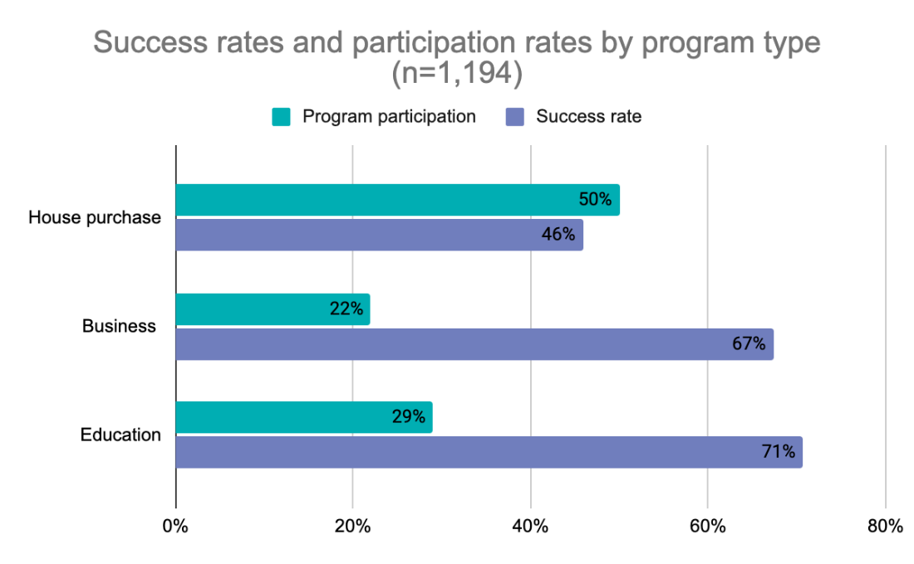

The program has varying success for different groups, depending on gender, race/ethnicity, and age.

Through reviewing comparison data from the FAIM database of those who entered the program and those who successfully completed the program, we can garner if there are any patterns in the characteristics of successful and unsuccessful participants to shed light on whether more robust program supports may be created to increase success rates for particular populations.
Males have almost a 10% higher success rate than females in the FAIM program, while females make up a much higher percentage of program participants (71% overall). This points to a greater opportunity to inquire further with program staff, participants, and to possibly create some targeted support programming for female participants.
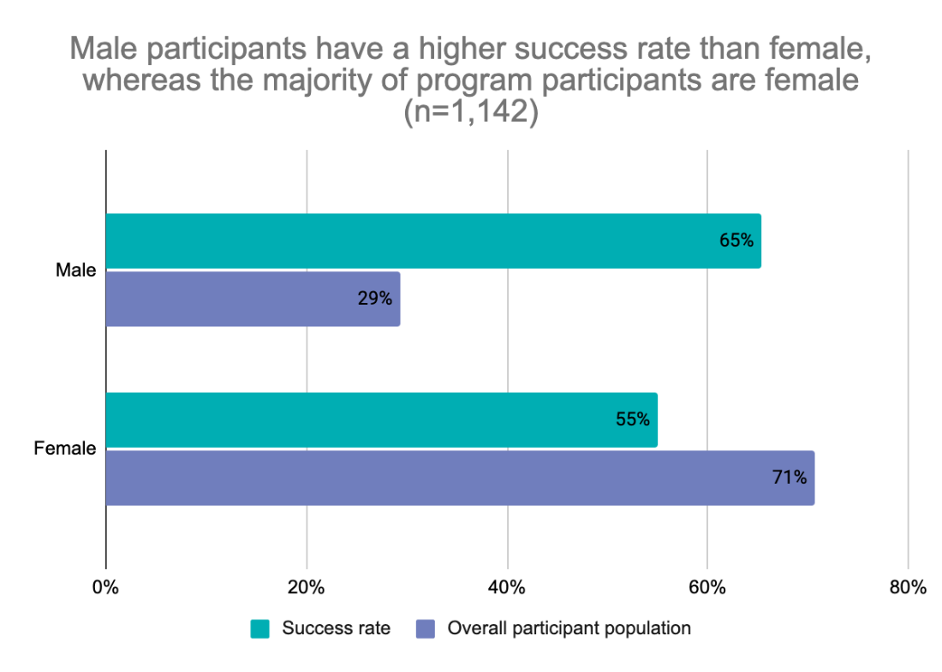
The chart below shows that the program is most effective in serving Latino/Hispanic, Asian/Pacific Islander, and White participants. It is not as successful in achieving the same outcomes for its Multiracial, Native American/Alaskan Native and Black/African American participants.
This may be influenced by the specialty programs that exist for particular populations to offer additional supports such as the Asian Media Access, and Neighborhood Development Alliance which has a program specifically for Latino/Hispanic community members. This may also point to opportunity to create additional programming to support particular racial/ethnic groups to increase success rates.
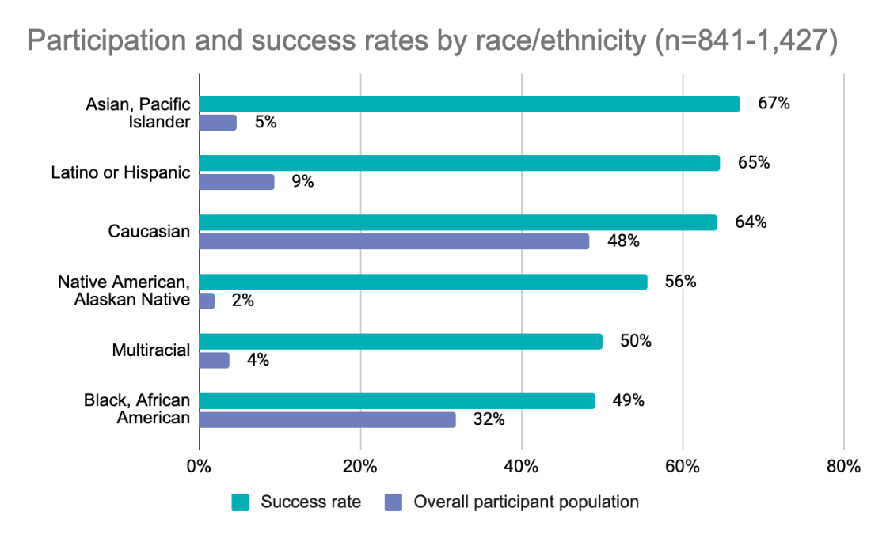
Participants 19 years old and under had the highest completion rates of any age group, however they make up a very small percentage of participants (6%). One possible explanation for this is that they are more likely to be learning new financial habits with support, rather than unlearning practices built up over time.
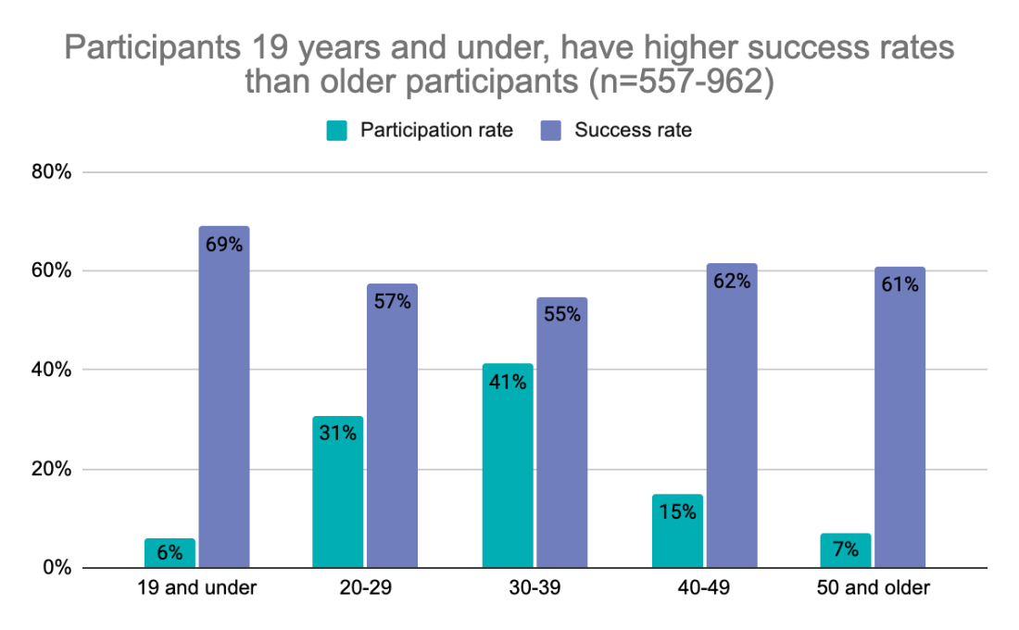

Credit scores upon entry are not a clear predictor of success.

Credit scores from the time of application were used to calculate success rates to see if additional supports for particular score ranges may be needed or beneficial. However, there’s not a clear trend in the data that would lead to taking additional action in this area. Success rates are higher for those with credit scores above 740, however the percentage of participants in this range is only around 15%, and because of the variation in success rates at lower levels, a targeted intervention based on this indicator does not seem strategically warranted.

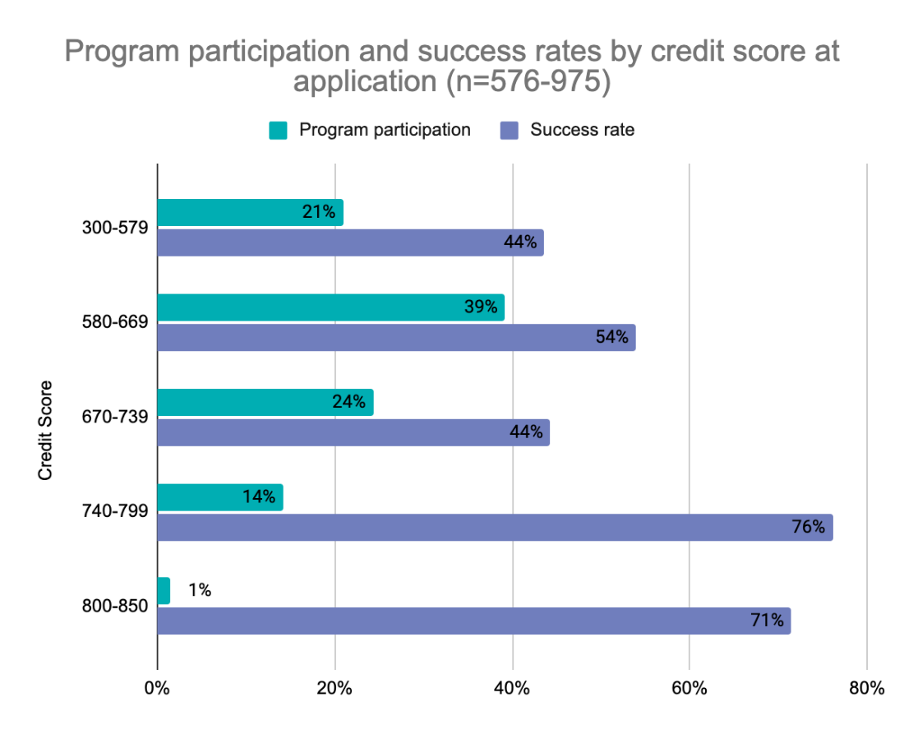

Participants with past financial experiences such as the use of bank accounts, and home ownership are more likely to succeed in the program.

Participants take an extensive questionnaire during the application process for the FAIM program. Data for all participants from January 2011 to December 2019 shows that participants who had a checking and/or savings account have higher rates of successfully completing the program than those who have not. These numbers indicate that there could be an opportunity for additional targeted education, support, and/or coaching for participants new to formalized banking activities.
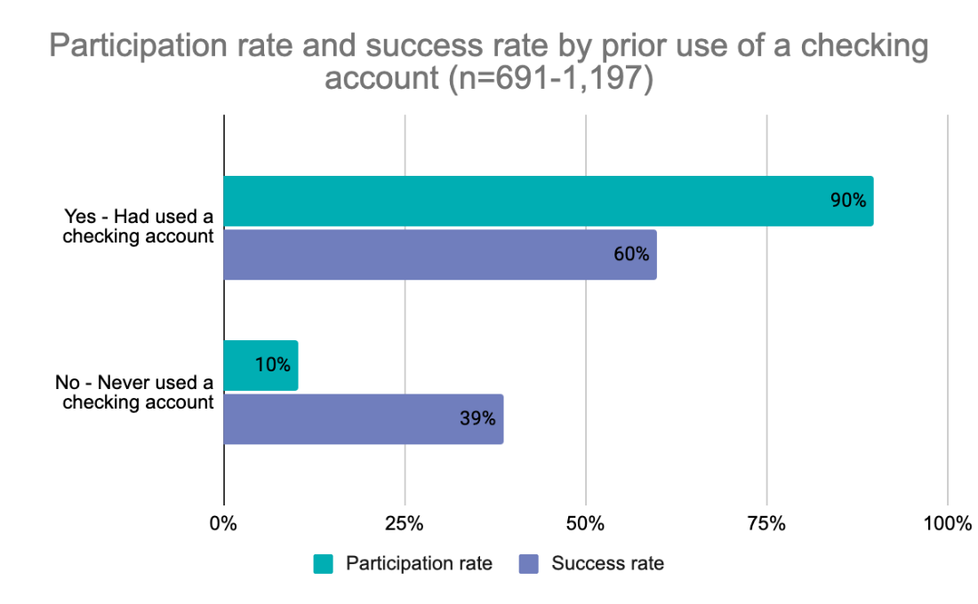

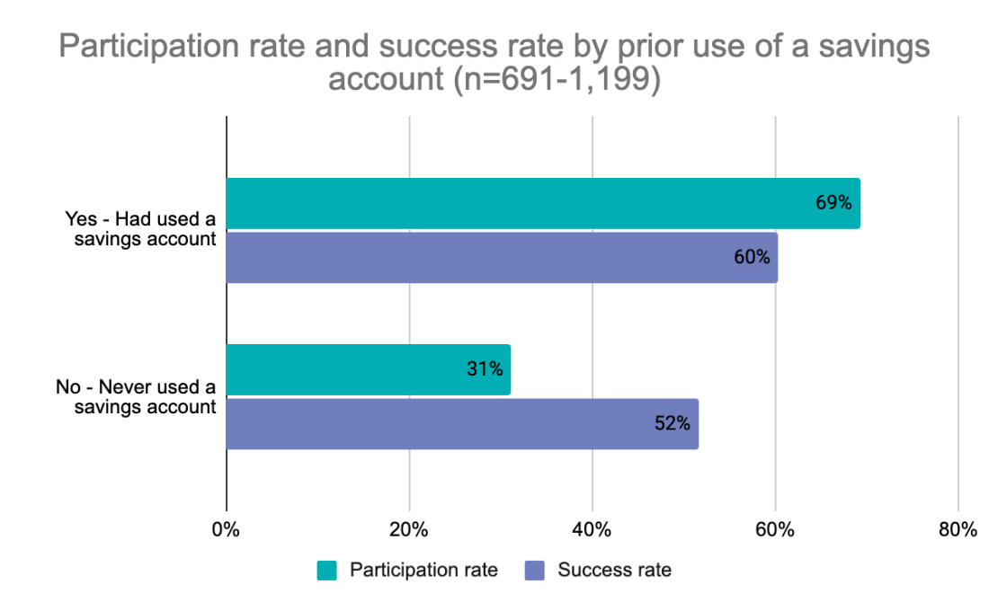
Participants who owned a home at time of entry have a much higher likelihood of succeeding in the program, however they make up a small percentage of participants. This is unsurprising as home owners are likely accustomed to saving money on an ongoing basis, and likely have greater access to capital and/or social supports. Given the low success rates for those who do not currently own a home at entry, there is an opportunity to provide additional education, supports, or tracking for these individuals upon entry to the FAIM program.
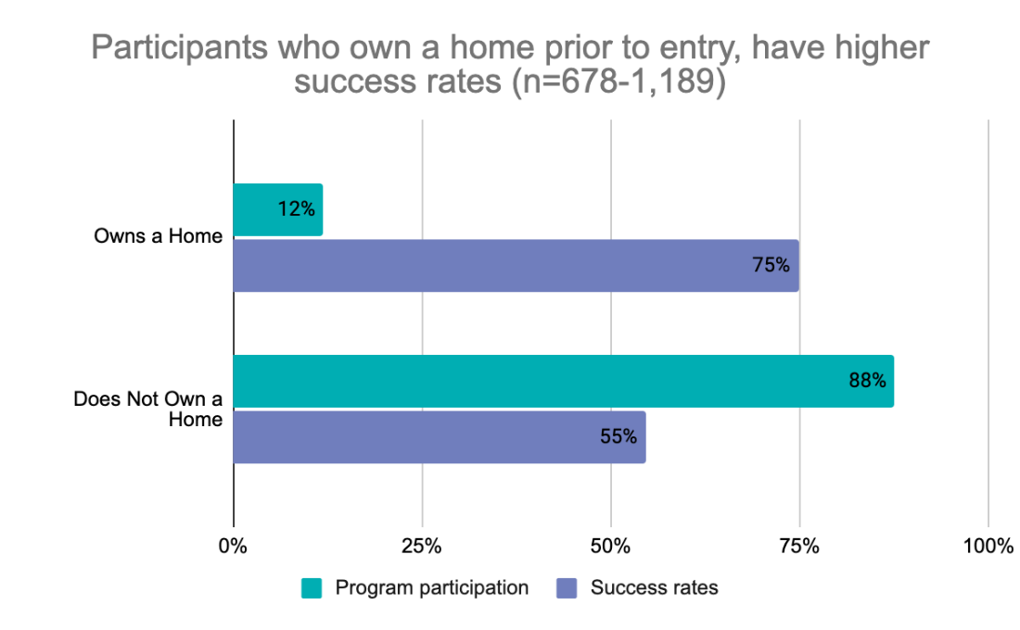
Other indicators that were examined include: income level at time of application, prior use of the earned income tax credit, car ownership, educational attainment, and employment status. There did not appear to be any clear difference in success rate as related to these factors.

Participants report long-term positive outcomes after program completion

The majority of survey respondents (77%) successfully completed the FAIM program. A small number of unsuccessful respondents (n=8) reported completing the savings portion of the FAIM program, but being unable to complete their asset purchase afterwards due to circumstances such as financing not being approved by the bank, family circumstances, or determining that their business would not be financially viable. A few survey respondents (n=5) reported being currently enrolled in the program, and began the program in December 2019.

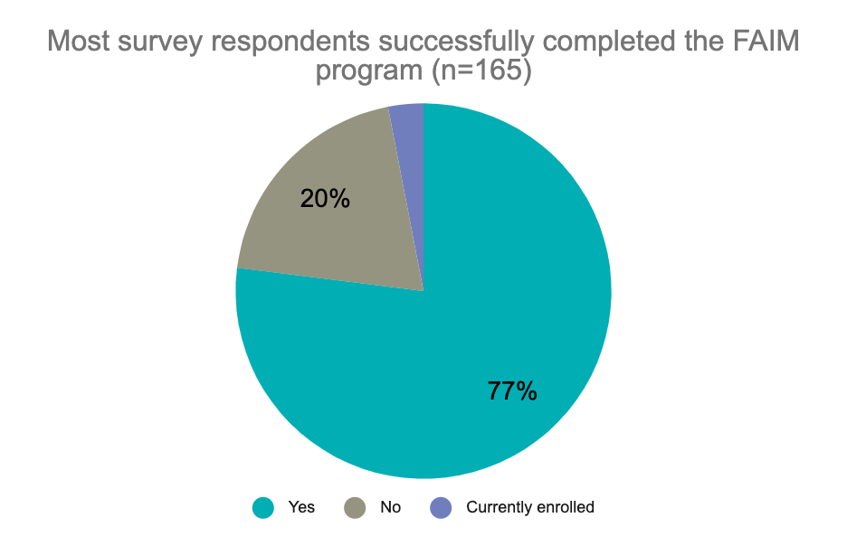

The majority of survey respondents (53%) participated in the home buyer asset program, followed by an even split of business development (23%) and post-secondary education participants (23%), and with one participant (1%) saving towards a car (this is a locally funded program).
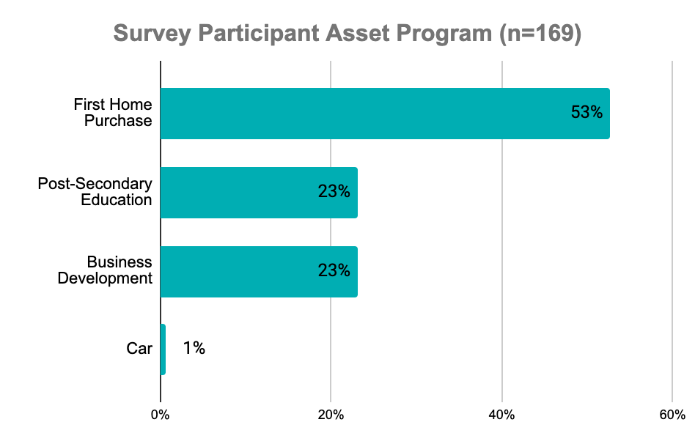
Survey respondents reported long-term positive outcomes after participating in FAIM. The large majority of successful respondents in the home ownership or business development tracks reported retaining their home or business (94%). Several of the small number who no longer have their home shared that they purchased a home worth more, thereby increasing their net worth (4%). As one participant shared, “I sold the home and moved into a new home of higher value. I was able profit about $20,000 from the sale of that home!”

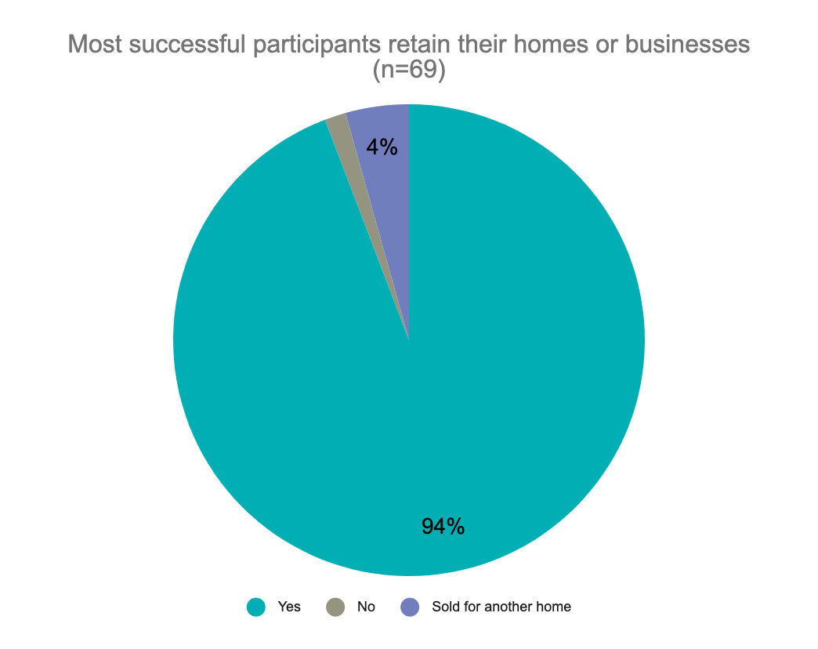

Of the survey respondents who successfully completed the FAIM educational program, 88% also fully completed their post-secondary educational program. Of those who successfully completed the FAIM post-secondary educational program, all of the survey respondents (n=27, 100%) shared that their degree has been useful in meeting their work or career goals.
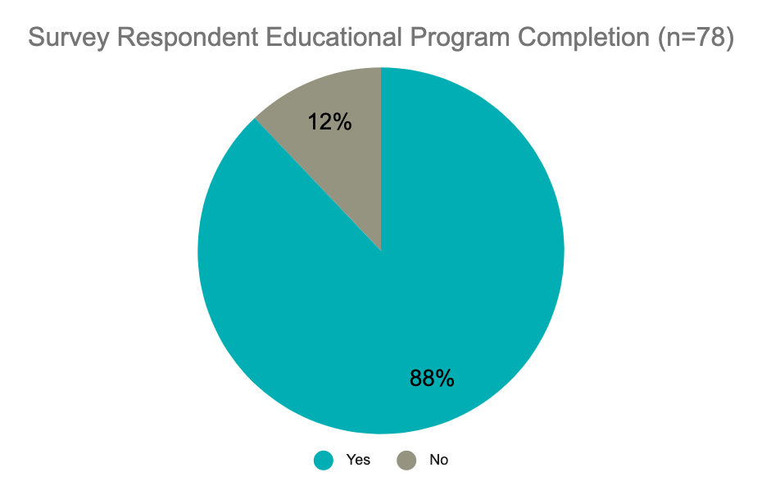

Former participants felt supported by the FAIM program elements.

Past participants shared that the savings match dollars were the most helpful part of the FAIM program, followed by the financial literacy education, and finally the 1:1 coaching was still rated highly. The 1:1 coaching is typically just a few meetings per participation period, which may be why it was not seen as the most supportive element of the program.
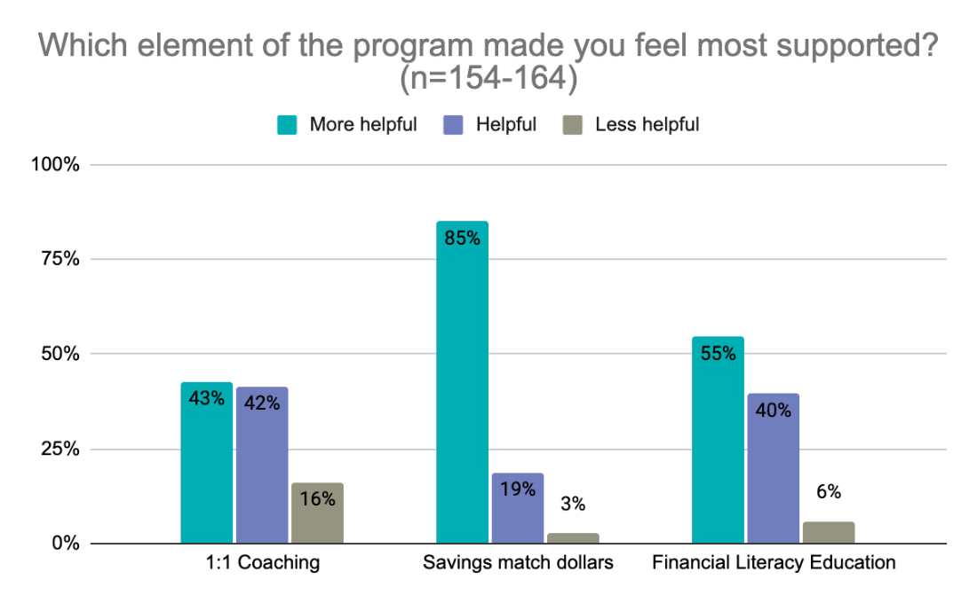
When survey respondents were asked to share one thing about the program they would improve upon, many answered “nothing.” As one respondent stated, “I don’t have any real changes to suggest — I appreciated how the FAIM program supported my financial goals.” Another shared, “Nothing; the program is amazing: liked the financial literacy and loved the savings match!”
Around the same number of survey respondents shared that they would like to see more coaching and support available to participants. These responses encompassed requests for additional home ownership and business mentoring (including after the program has ended to help participant businesses be successful). As one respondent shared, “I also needed human capital, which is ongoing business mentoring and education. Not only lack of funding, I failed to build the connection needed to bring the business idea fruition. Not everyone thinks my business idea was a good idea, and I needed someone who is experienced in the industry or entrepreneurial path to feel like I am in the stable boat, instead of riding a boat that may be sinking.”
Several respondents shared the need to have a greater consistency of which coach participants are working with, respondents cited being switched between individuals, and also high turnover rates, leading to inconsistent support. As one respondent wrote, “I would have liked more contact with the advisors - people came and went and it was hard to get consistent advice, let alone sustain a connection. When someone changed jobs or assignments or went on leave, the new person wasn't very up to speed on my situation.”
Other respondents suggested personalized financial counseling, the separation of programming specifically to provide support targeted to the particular asset program, or additional contact points. A survey respondent shared, “I would like to see more follow up communication with the staff. It seemed, once you signed up, unless you had questions and contacted the staff, you were left alone. A periodic 5 min call would be great to just touch base.”
Smaller themes that emerged included expanding funding and locations for the program to increase opportunities to serve additional participants, increased marketing of the program, and expanded program duration including allowing participants more of a grace period after completing their saving period for them to use the funds. As one respondent share, “I wish this program will consider some extenuating circumstances for participants who aren't able to utilize the fund before the due date. A little bit of extension or some flexibility would be helpful, rather losing the benefits for no good reason. This is my situation and I’m really sad to be losing the fund I worked hard to participate in for 2 years.” Improved operations were also a minor theme, with suggestions such as: additional bank locations, evening hours, online classes, and increased staff availability.
One minor theme (mentioned by five survey respondents) that merits mention because of its implications for participants is concern that applicants are not being properly screened or informed at the start to ensure their success in using/receiving their match dollars at the end of the program. As one respondent shared, “One of the worst experiences I have had. Due to an error on the programs end i was not eligible for my matched funds, i was putting money in that account at a time when i did not really have the funds to do it but thought it was going to benefit me and in the end it did not. I would not recommend this program to others because I believe it is poorly run.” Another shared, “[Please ensure] that the workers do their due diligence to make sure that the clients are taken care of and are not wasting their time and money with this program and not receive anything in the end and be told that you do not qualify after you are already accepted into the program and have been saving money only my part of the money was returned to me, I did not receive any money from this program.”

Former participants made lasting changes to their financial assets and wellbeing.

Survey respondents were asked about their financial behaviors since the program ended. Overall, the majority of participants shared positive outcomes and behaviors in alignment with the teachings of the FAIM financial literacy course.
The large majority of survey respondents shared that they’ve been engaged in actively contributing to improving/building upon their credit score in positive ways, and have also taken actions such as reading their credit report, and repairing errors. Respondents also reported not using predatory lending services.
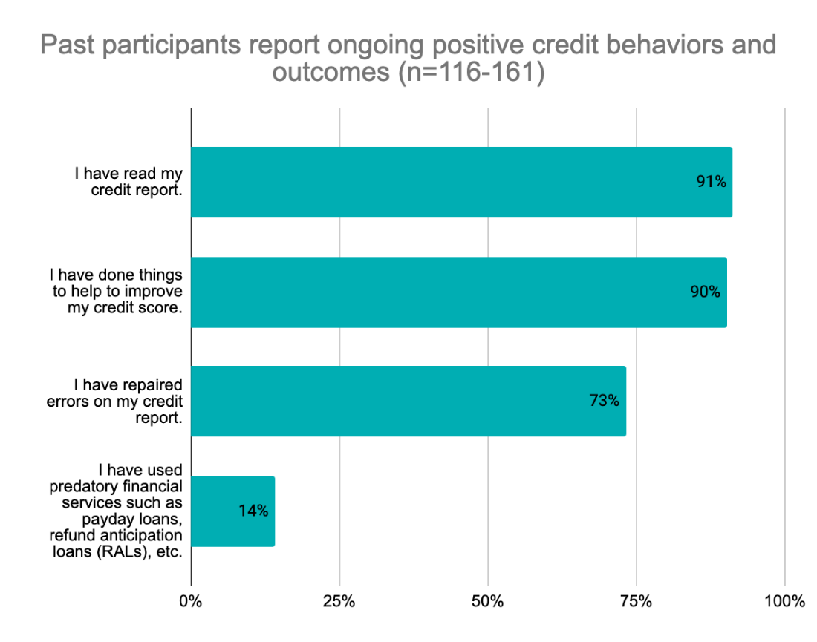
The purpose of the FAIM program is to increase opportunities for individuals and families to increase their assets. The majority of survey respondents shared that overall, they have been increasing their assets since exiting the FAIM program. Participants shared that they have been saving money for emergencies and retirements. A smaller majority have also acquired additional assets to build wealth.
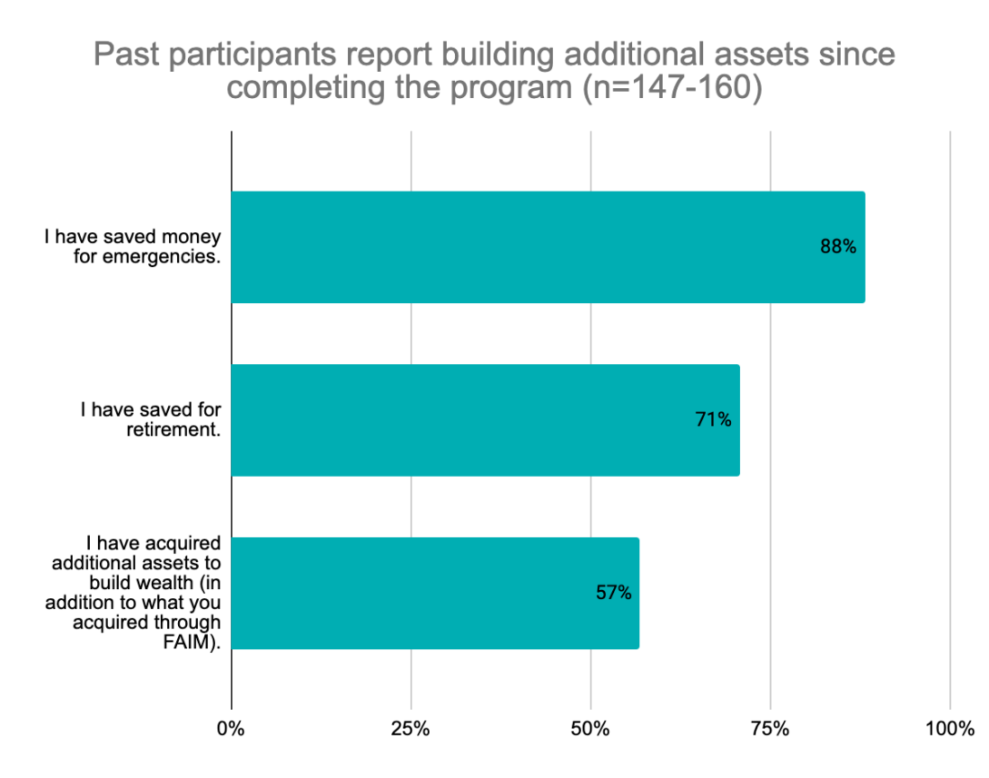
As one former participant shared via email,
“My wife and I were first informed of FAIM through a banker friend that was familiar with the program. The FAIM expectations and criteria were presented in an easily understood format through friendly interactions with the program's administrators. Had it not been for FAIM we'd still be renting, paying more for a property that isn't ours while barely being able to screech by with our monthly obligations. After FAIM we have a home to call our own and the means to save each month which directly contributes to an improved future for our children and the basis for them to build generational wealth.”
Survey respondents shared that overall, they have assets including a vehicle, investments, and/or a home. Few respondents have a business or own residential rental properties.
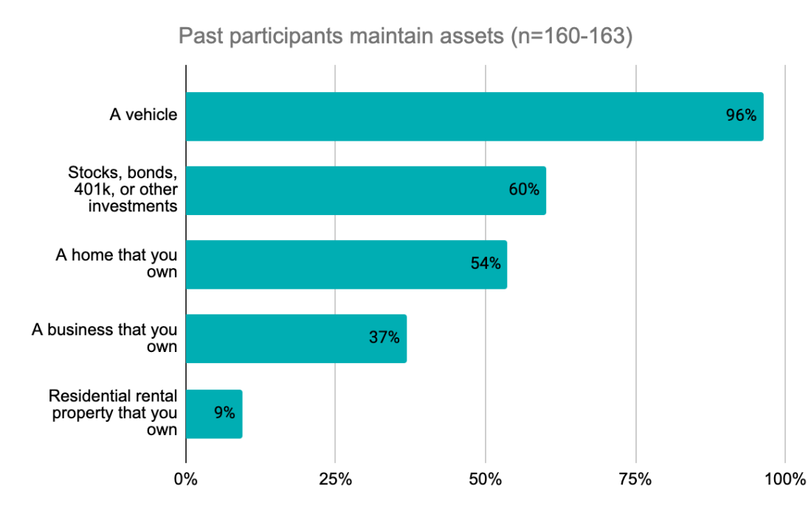
The majority of survey respondents reported holding health and/or life, disability, and/or renters' insurance. Participants are taught about these tools as part of the financial literacy course through FAIM.
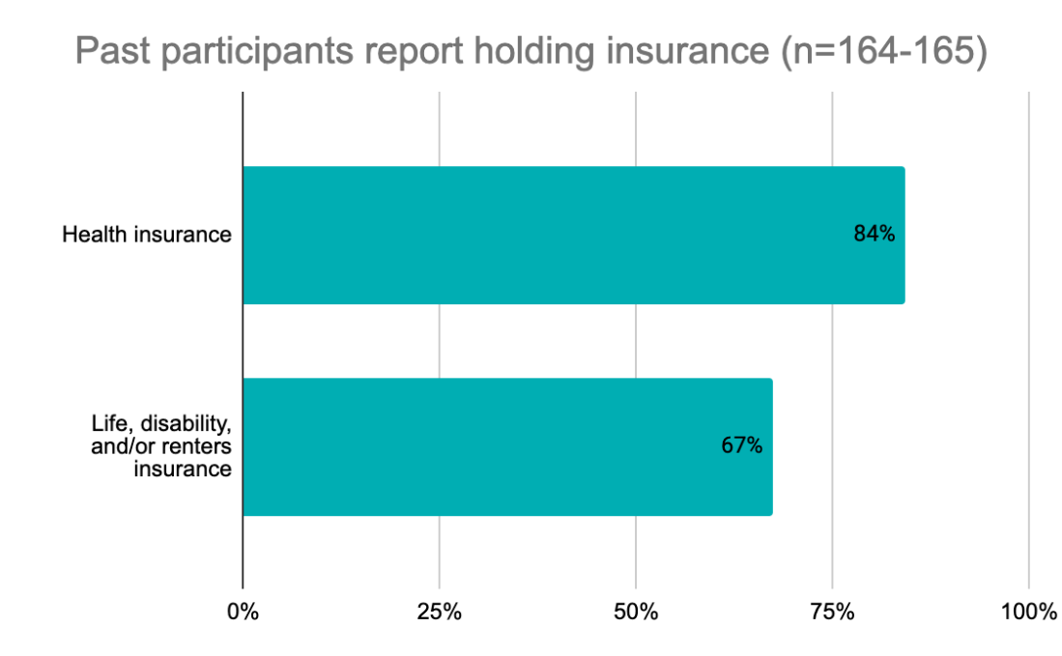
Respondents were asked a series of questions to assess their use of financial tools in ways that benefit their overall financial health. All but a few survey respondents maintain a checking account, a savings account, and credit cards.
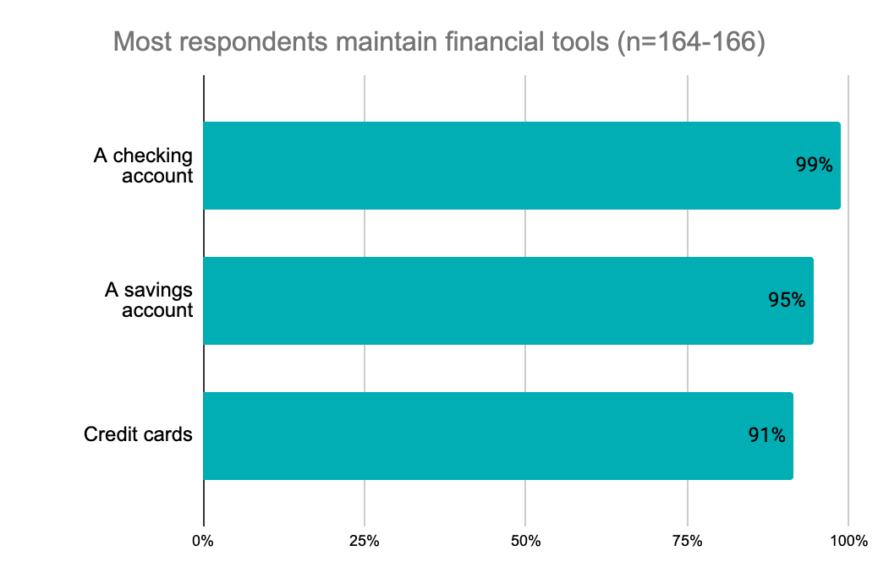

More importantly, the majority of respondents do not currently have overdue debt. However, a small majority (51%) are currently carrying a credit card balance for more than a month which is likely a reflection of the current economic state more than a year into the pandemic at the time of survey distribution.
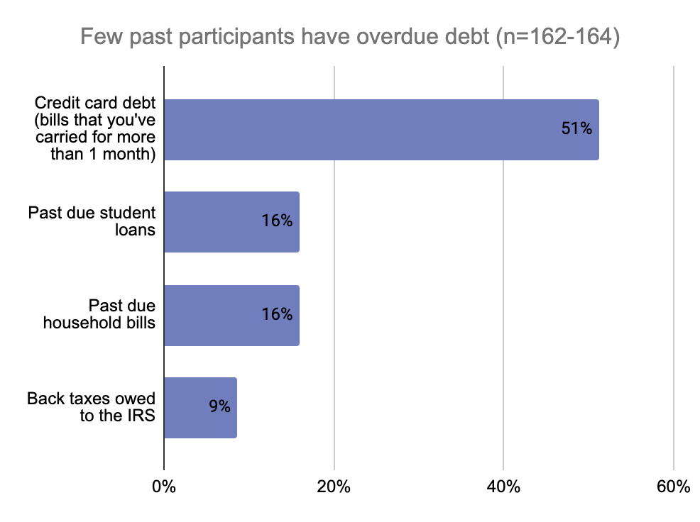

Student loans are the most commonly held form of debt carried by survey respondents. Few respondents reported carrying other forms of debt such as other loans, debt from family and friends, and payday loans. Of respondents who successfully completed the program, none reported using a payday loan since completing the program.
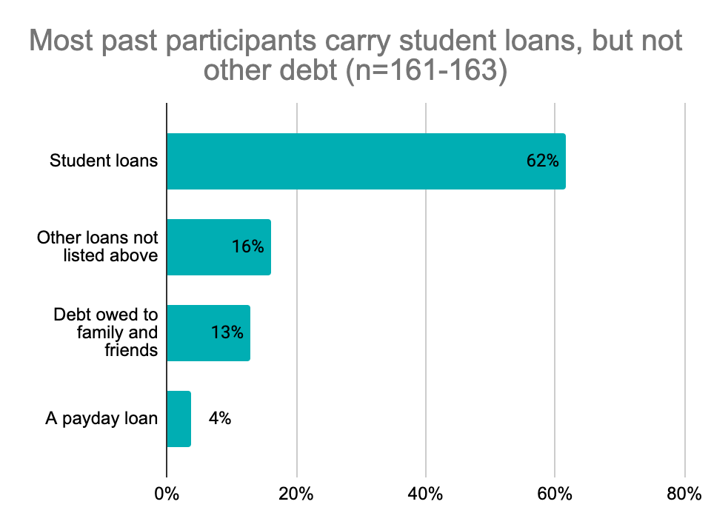
Tax credits and public assistance are a proxy for respondent income levels. Survey respondents were asked to respond about the most recent tax year. About half of respondents access the Federal Earned Income Tax Credit (which involves an income level of between $15,820 for a single individual up to $56,844 for a married couple with three children). Fewer respondents (36%) have received the State Working Family Tax Credit (income level is for a couple with income between $23,100 with no children and $58,000 with 3 or more children). A similar number of respondents (30%) received the Childcare Tax Credit (for families paying for childcare).
Roughly a fifth of respondents (19%) reported currently receiving food support and less than 10% (8%) of respondents are receiving state supplemental income.
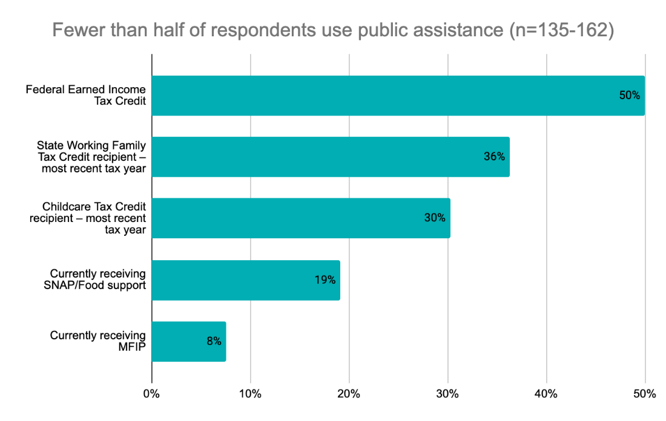
The majority of respondents (60%) reported being employed full time (35 or more hours per week), with an additional 5% self-employed full-time. Around 7% of respondents reported being unemployed, which is slightly higher than the state rate of 4.2% in March 2021.
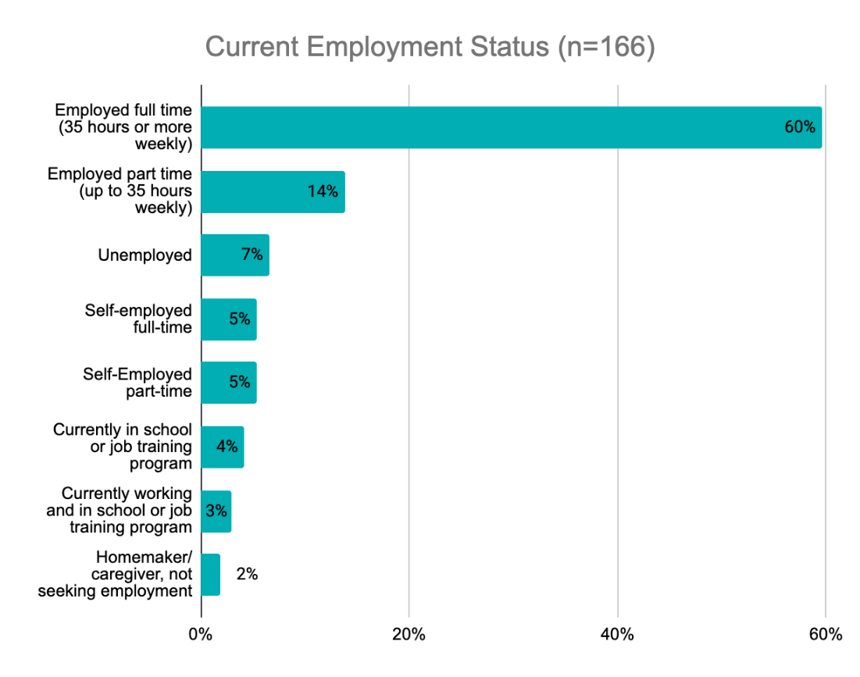
The majority of respondents (57%) reported earning over $30,000 annually, and only 13% reported earning $15,000 or less. The question focused on individual income, not household income.
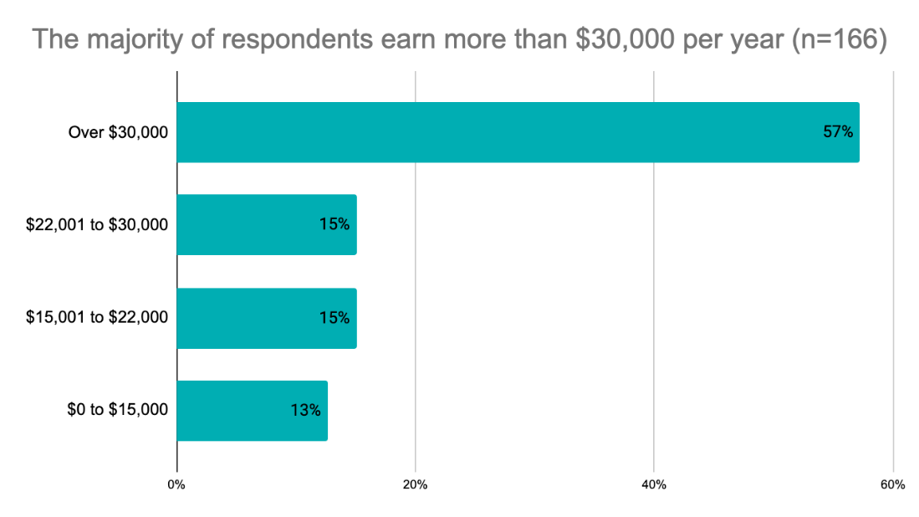
Overall, these numbers, in combination with the asset and financial indicators previous discussed show that past participants who responded to the survey report increased assets and solid financial standing, even with the current financial environment over a year into the pandemic.
When participants were asked to share how (if at all) participating in the FAIM program changed their lives, responses varied. The majority shared the obvious of helping them to achieve ownership of their chosen asset, or the completion of their degree. As one respondent wrote,
“I had the motivation to start a business, but the funding was another story. The FAIM program gave me the help that I needed. A boost! It was a lot of work writing my business plan but I am grateful that I did that work. I needed that roadmap for my business. I am glad that is a requirement of the program. I am now a woman entrepreneur business owner. FAIM was a big part of the why and how.”
Another strong theme that emerged was financial literacy skills that supported participants in achieving financial wellbeing. As one respondent shared, “It gave me the knowledge to understand how to manage and maintain my finances and have me the opportunity and support to start a business.”
Several participants also discussed the power of getting into the habit of saving money. As one shared, “Establishing the habit of putting money in my savings account, no matter how little the amount, every single month. Makes such a huge difference over time, little by little!”

Discussion
The FAIM program has the highest success rates for those in the education (71%) and business development programs (67%), with the first-time home buyer success rates being much lower at 46%. Survey participant responses point to an opportunity to change the application process for this program to better screen participants so that only those who are likely to succeed in obtaining access to loans to purchase a home at the end of the program are accepted. These rates may also point to a need for additional supports for those in the home buying program, or longer timelines (also suggested by survey respondents) given the amount of capital required to purchase a home.
Participant success rates vary by demographics and financial indicators at intake, pointing to an opportunity to offer greater supports for certain populations. Males have almost a 10% higher success rate than females in the FAIM program, while females make up a much higher percentage of program participants (71% overall). The FAIM program is most effective in serving Latino/Hispanic, Asian/Pacific Islander, and White participants. It is not as successful in achieving the same outcomes for its Multiracial, Native American/Alaskan Native and Black/African American participants. Given these findings the FAIM program may want to consider offering more targeted programming for individuals of certain demographic groups, perhaps partnering with specialized organizations, creating peer support groups of participants, or offering additional one to one coaching support.
Participants 19 years old and under had the highest completion rates of any age group, however they make up a very small percentage of participants (6%). This may prove to be a promising opportunity to expand offerings for younger participants as they are more likely to learn healthy financial habits from the start which can benefit them, and subsequent generations, from the beginning of their adult lives. This may also pair nicely with an expansion of the educational program, which has also proven to have the highest success rate. Given that participants can participate two times in a lifetime, this could be marketed as a starter opportunity to young participants.
Participants with past financial experiences such as the use of bank accounts, and home ownership are more likely to succeed in the program. Participants who had a checking and/or savings account have higher rates of successfully completing the program than those who have not. Similarly, participants who owned a home at time of entry have a much higher likelihood of succeeding in the program, however they make up a small percentage of participants. These numbers indicate that there could be an opportunity for additional targeted education, support, and/or coaching for participants new to formalized banking activities.
Past FAIM program participants reported lasting changes to their assets. The large majority of successful respondents in the home ownership or business development tracks reported retaining their home or business (94%), and an additional 4% shared that they sold their initial home and purchased a home worth more, thereby increasing their net worth. Of the survey respondents who successfully completed the FAIM educational program, 88% also fully completed their post-secondary educational program, and 100% of those shared that their degree has been useful in meeting their work or career goals.
Past participants shared that the savings match dollars were the most helpful part of the FAIM program, followed by the financial literacy education, and finally the 1:1 coaching was still rated highly. The 1:1 coaching is typically just a few meetings per participation period, which may be why it was not seen as the most supportive element of the program. Many respondents are happy with the program the way it is. Many others would like to see more coaching and support available to participants, including additional home ownership and business mentoring.
Former participants made lasting changes to their financial assets, behaviors, and overall financial wellbeing. The large majority of survey respondents shared that they’ve been engaged in actively contributing to improving/building upon their credit score in positive ways, and have also taken actions such as reading their credit report, and repairing errors. Participants shared that they have been saving money for emergencies and retirements, and have assets including a vehicle, investments, and/or a home. All but a few survey respondents maintain a checking account, a savings account, and credit cards. The majority of respondents do not currently have overdue debt. However, a small majority (51%) are currently carrying a credit card balance for more than a month which is likely a reflection of the current economic state more than a year into the pandemic at the time of survey distribution. Student loans are the most commonly held form of debt carried by survey respondents. The majority of respondents (60%) reported being employed full time (35 or more hours per week), with an additional 5% self-employed full-time. The majority of respondents (57%) reported earning over $30,000 annually.
These results show that the program supports participants to make lasting changes for the better in their lives, and that, with additional program supports, even more participants have the potential to create better financial lives for themselves.

Appendix: Participant survey Demographics
The following tables show the demographics of the survey respondents, and the overall program population served from January 2011 to December 2019. These tables serve as a reference point in order to understand in what ways the survey respondents vary from the overall population served by FAIM.
Age of survey respondents
20-29 | 16% | 26
30-39 | 40% | 68
40-49 | 28% | 47
50 years and older | 15% | 25

Age of overall program participants
19 and under | 6% | 58
20-29 | 31% | 296
30-39 | 41% | 396
40-49 | 15% | 143
50 and older | 7% | 69

Individual income of survey respondents
$0 to $15,000 | 13% | 21
$15,001 to $22,000 | 15% | 25
$22,001 to $30,000 | 15% | 25
Over $30,000 | 57% | 95

Household income at program entry
Less than $15,000 | 28% | 316
$15,000 to $30,000 | 43% | 487
$30,000 to $45,000 | 23% | 258
$45,000 to $60,000 | 4% | 49
More than $60,000 | 2% | 12

Gender of survey respondents
I have another gender not listed here | 1% | 3
Male | 18% | 30
Female | 80% | 133

Gender of overall program participants
Female | 71% | 807
Male | 29% | 335
*An “other” option is not provided to participants in the program application

Race/ ethnicity of survey respondents
White | 46% | 78
Black | 28% | 44
Hispanic or Latinx | 12% | 18
Asian or Pacific Islander | 4% | 7
American Indian or Alaskan Native | 2% | 3
I prefer not to say | 3% | 5
I have another race/ethnicity not listed here | 1% | 1

Race/ ethnicity of overall program participants
Caucasian | 48% | 692
Black/African American | 32% | 454
Latino or Hispanic | 9% | 133
Asian/Pacific Islander | 5% | 67
Multiracial | 4% | 54
Native American/Alaska Native | 2% | 27

Education level of survey respondents
Less than a high school degree | 1% | 2
High school diploma/GED | 8% | 13
Some college | 17% | 29
AA Degree (2-year degree) | 24% | 40
BA/BS Degree (4-year degree) | 27% | 46
Completed a masters, doctorate, or professional post-graduate degree | 24% | 40

Education level of overall program participants
Less than a high school degree | 9% | 158
High school diploma/GED | 20% | 326
Some college | 35% | 592
AA Degree (2-year degree) | 18% | 293
Vocational School Diploma / Degree | 4% | 64
BA/BS Degree / Graduated four-year College Some Graduate School / Attended Graduate School MA/MS, etc. Graduate Degree(s) | 14% | 237

Relationship status of overall program participants
Single, never married | 56% | 984
Married | 25% | 433
Separated | 4% | 68
Divorced | 15% | 264
Widowed | 1% | 10
Other | 0% | 3
*This item was not asked about on the survey

Employment status of survey respondents
Employed full time (35 hours or more weekly) | 60% | 99
Employed part time (up to 35 hours weekly) | 14% | 23
Self-employed full-time | 5% | 9
Self-Employed part-time | 5% | 9
Currently working and in school or job training program | 3% | 5
Currently in school or job training program | 4% | 7
Homemaker/ caregiver, not seeking employment | 2% | 3
Unemployed | 7% | 11

Employment status of overall program participants
Full Time Employed | 48% | 847
Part Time Employed | 45% | 785
Unemployed | 1% | 18
Student | 1% | 13
Other | 5% | 88

Completion rates of survey respondents
Yes | 77% | 127
No | 20% | 33
Currently enrolled | 3% | 5

Completion rates of overall program participants
Yes | 688 | 58%
No | 506 | 42%

The “other” category had a success rate of 67%, however only encompasses 3 accounts, and therefore is too small to make any meaningful conclusions.
Participant family structure was also examined to look for pronounced differences in success rates, however, the data paints a mixed picture and would be challenging to design effective programming supports for participants.
The use of pre-paid debit cards and using direct deposit were also examined, but no clear differences in success rates were observed.
https://mn.gov/deed/data/current-econ-highlights/state-national-employment.jsp

